1 - Personal Well-Being

The well-being of leaders is of primary importance. The nature of the leader’s presence, the quality of the self that is brought to bear on the work, the relationship, or the crisis, determines, more than any other factor, what happens next. How are you? Rate each component.

Autonomy Scale
❒ 1 ❒ 2 ❒ 3 ❒ 4 ❒ 5
Encumbered & Constrained Free & Effective

Competence Scale
❒ 1 ❒ 2 ❒ 3 ❒ 4 ❒ 5
Unprepared & Anxious Ready & Able

Relatedness Scale
❒ 1 ❒ 2 ❒ 3 ❒ 4 ❒ 5
Disconnected & Unseen Belonging & Seen

Total Score __________ Lowest Score __________ Highest Score __________

Personal well-being requires all three components. Our current crisis has acutely diminished all three components for most people but many are adjusting. A sum of 12 or higher is most desirable. Did you score lower than 3 on any one component? Which components are low? What can you do to raise them?

________________________________________________________________________________________________________

________________________________________________________________________________________________________

________________________________________________________________________________________________________

________________________________________________________________________________________________________

________________________________________________________________________________________________________

________________________________________________________________________________________________________

________________________________________________________________________________________________________

________________________________________________________________________________________________________
2 - Leadership Engagement

During this crisis, are you functioning as an Under-Reactive Leader, an Over-Reactive Leader, or an Adaptive Leader? Check the descriptors that best describe your current engagement style.

Adaptive Under-Reactive Over-Reactive
◻️ Focused ◻️ Uncertain ◻️ Emotional
◻️ Emotionally Self-Aware ◻️ Wait and See ◻️ Overwhelmed
◻️ Opportunity Driven ◻️ Dismissive ◻️ Creating Panic
◻️ Strategic (long-term) ◻️ Uncommunicative ◻️ Disorganized
◻️ Reality-Testing

Which kind of leadership engagement best describes your current style? The Adaptive Leader provides Clarity, fosters Relatedness, and encourages Autonomy. Check the behaviors that best describe your adaptive style.

Clarity Relatedness Autonomy
◻️ Communication ◻️ Connections ◻️ Choice
◻️ Information ◻️ Empathy ◻️ Empower
◻️ Engagement ◻️ Mindset ◻️ Wins
◻️ Dependability ◻️ Goals ◻️ Trust

Which behaviors are your strongest and consistent?

_________________________, _________________________, _________________________, _________________________

Which behaviors are your weakest and most inconsistent?

_________________________, _________________________, _________________________, _________________________

How can you adjust these behaviors?

________________________________________________________________________________________________________

________________________________________________________________________________________________________

________________________________________________________________________________________________________

________________________________________________________________________________________________________
3 - Well-Being vs Engagement

The healthy Adaptive Leader is engaged in the work of self-care and ministry.

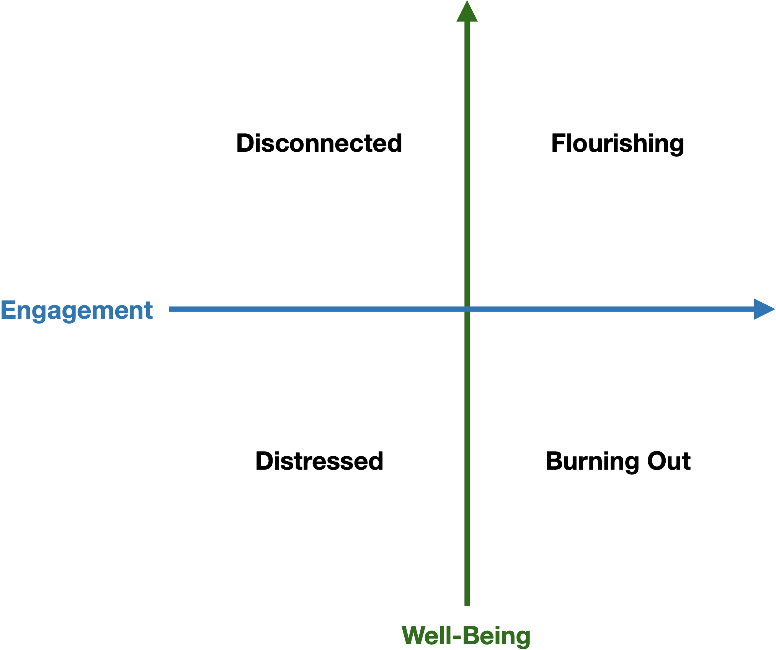

Flourishing = High Engagement + High Well-being
Burnout = High Engagement + Low Well-being
Disconnected = Low Engagement + High Well-being
Distressed = Low Engagement + Low Well-being

Which quadrant do you most identify with? Using Personal Well-Being (1) and Leadership Engagement (2), how can you raise your well-being or engagement style?

________________________________________________________________________________________________________

________________________________________________________________________________________________________
4 - The Five Functions

Our current crisis has five primary functions as it relates to our churches. It:
- Reveals - the things that were both weak and strong
- Accelerates - the things that were already in motion
- Forces - the things that were slow or too scary or new
- Flattens - structures and hierarchies, and decentralizes models
- Focuses - the things that are of most importance

What is being revealed?

________________________________________________________________________________________________________

________________________________________________________________________________________________________

What is accelerating?

________________________________________________________________________________________________________

________________________________________________________________________________________________________

What is being forced?

________________________________________________________________________________________________________

________________________________________________________________________________________________________

What is being flattened?

________________________________________________________________________________________________________

________________________________________________________________________________________________________

What is of most importance?

________________________________________________________________________________________________________

________________________________________________________________________________________________________
5 - Timing Is Everything

Einstein has famously said: “If I had an hour to solve a problem, I'd spend 55 minutes thinking about the problem and 5 minutes thinking about solutions.” Similarly, Bill Gross’ research reveals that the most important factor for organizational success is timing. Bill Gross found that the second most important factor is the team, the implementation. Jim Collins calls this “getting the right people on the bus.” And a distant third are ideas. What good is a great idea that is not needed in the times we’re in? Or an idea that can’t be implemented well? The Bible’s word for Timing is Kairos, as in, “In the fullness of time (kairos), God sent His Son.”

Define this moment in time. What is happening? What is needed? What is relevant?

________________________________________________________________________________________________________

________________________________________________________________________________________________________

________________________________________________________________________________________________________

________________________________________________________________________________________________________

________________________________________________________________________________________________________

________________________________________________________________________________________________________

________________________________________________________________________________________________________

________________________________________________________________________________________________________

________________________________________________________________________________________________________

________________________________________________________________________________________________________

________________________________________________________________________________________________________

________________________________________________________________________________________________________

________________________________________________________________________________________________________

________________________________________________________________________________________________________

________________________________________________________________________________________________________
6 - Outcome Goals

Studies show that 2-3 outcome goals are the optimal number of goals. Covey calls these WIGs or Wildly Important Goals. After the 3rd goal, returns start diminishing and goals become unachievable in the pace of life and under the demands of other responsibilities. Outcome goals follow this formula: We’re at X. We’ll get to Y by Z. For example, We have 3 Zoom small groups (X). We will get to 7 Zoom small groups (Y) in 7 weeks (Z). Having considered the timing factor, what are 2-3 outcome goals for the church?

1. _____________________________________________________________________________________________________

2. _____________________________________________________________________________________________________

3. _____________________________________________________________________________________________________

Outcome goals are comprised of smaller, specific tasks and processes. List as many tasks and processes you need to do to accomplish your goals. After each task/process item, list a name and deadline.

1. _____________________________________________________________________________________________________

Task/Process Who Deadline

________________________________________________ ____________________________________ ____________________

________________________________________________ ____________________________________ ____________________

2. _____________________________________________________________________________________________________

Task/Process Who Deadline

________________________________________________ ____________________________________ ____________________

________________________________________________ ____________________________________ ____________________

3. _____________________________________________________________________________________________________

Task/Process Who Deadline

________________________________________________ ____________________________________ ____________________

________________________________________________ ____________________________________ ____________________

Review

ONE
Personal Well-Being
+
Adaptive Leadership Engagement
=
Flourishing Leader

TWO
Timing
+
Goals
=
Flourishing Church

