Relational Wisdom- Relational Wisdom 360
What Is Relational Wisdom?
Relational wisdom, in essence, is the desire and ability to obey Jesus’ timeless command, “You shall love the Lord your God with all your heart … and love your neighbor as yourself” (Matt. 22:37-39).
In modern terms, relational wisdom may be defined as your ability to discern emotions, interests and abilities in yourself and others, to interpret this information in the light of God’s Word, and to use these insights to manage your responses and relationships successfully.

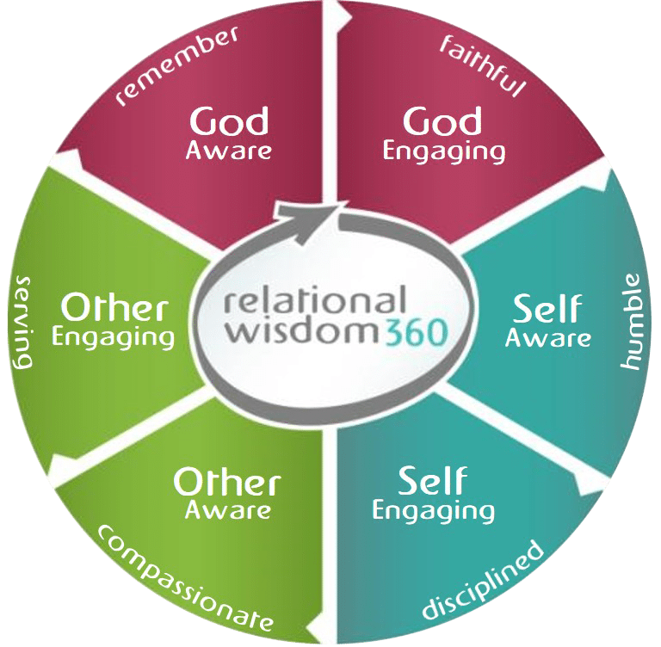

Six Relational Disciplines
From Genesis to Revelation, Scripture teaches us how to be faithful to God, discipline ourselves and serve the people around us.
This teaching may be summarized as six relational skills or disciplines: God-awareness and God-engagement, self-awareness and self-engagement, and other-awareness and other-engagement.
If we neglect these disciplines, our lives are often characterized by aimlessness, shallow relationships and conflict. But when we cultivate these disciplines, we are more likely to enjoy deep friendships, intimate marriages, joyful parenting, fulfilling careers and, most importantly, a compelling witness for Christ.

