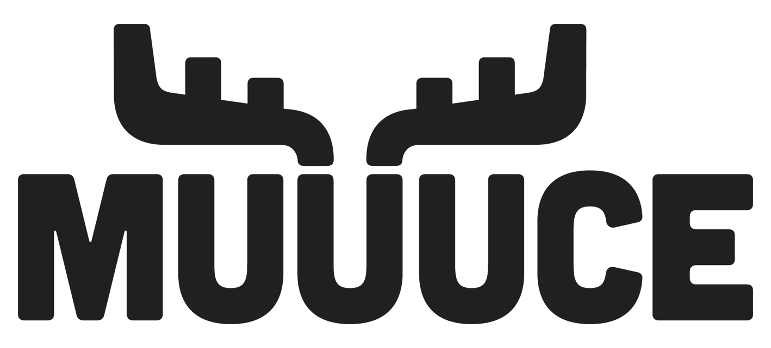

August 10-12, 2023
Buffalo Covenant Church

MUUUCE Registration Packet

This packet is for the MUUUCE point person at each church
(i.e. youth pastor or church leader).

MUUUCE stands for the Most Unbelievable, Ultimate, Urban(ish) Camping Experience. This incredible event is designed specifically with Northwest Conference middle schoolers in mind. It’s three days of crazy middle school fun, woven with worship experiences, challenging talks, and small group conversations! It’s a great way to kick off the fall ministry season. MUUUCE is a ministry of the Northwest Conference of the Evangelical Covenant Church.

This packet includes:
- Highlights
- Registration Process
- Registration and Payment Policy
- Student Registration Packet
  - Student Registration
  - Parent or Legal Guardian Consent & Medical Release
  - Student Standards of Personal Conduct
- Adult Leader Registration Packet
  - Adult leader registration form
  - Adult leader health form
  - Adult leader background check verification form (to be completed by lead pastor or church administrator)

THE HIGHLIGHTS
Who can attend: | Students entering 6th grade in the fall of 2023 to those graduating from 8th grade in the spring of 2023.
Dates: | August 10-12, 2023. Thursday afternoon through Saturday noon.
Registration: | All registrations must be connected to a church youth group and go through our registration platform.  The registration cost includes:  - Meals (Thursday Welcome Party, dinner, all day Friday and Saturday breakfast).  - Housing (at Buffalo Covenant)  - Valley Fair amusement park  - MUUUCE t-shirt  - Students will want to bring extra spending money for the various concession stands. Valley Fair does not accept cash. However, cash can be turned into cards at kiosks in the park. https://www.valleyfair.com/cashless
Cost: | $130 per person. There are no refunds, but name/attendees can be changed.
Adult Leaders: | Leaders must be at least 18 years old and must have completed a background check less than 24 months prior to the start of MUUUCE.  There must be at least one leader for every eight students, based on gender. This means you must have both male & female leaders if you have both male & female students attending. If you don’t have both male & female leaders, please contact MUUUCE@northwestconference.org and we’ll try to connect you with another group.
Location: | Buffalo Covenant Church  1601 CR-25 N  Buffalo, MN 55313  Buffalocov.org
Housing: | Students and leaders will be housed at Buffalo Covenant Church.
Transportation: | Groups are responsible for getting themselves to Buffalo Covenant. MUUUCE will provide transportation to and from Valley Fair.
Questions: | muuuce@northwestconference.org
News & Info: | For the latest news, Q&A, and other info:  - MUUUCE website: https://www.northwestconference.org/event/muuuce-2023/  - Sign up for the NWC Youth Ministry Update email: www.northwestconference.org  - Sign up on Covyouth.com and look for the NWC section.

MUUUCE Registration and Payment Policy

The following policy details terms and conditions are applicable to Covenant churches participating in MUUUCE. Groups choosing to register for MUUUCE should review this policy before registering. All registrations must be connected to a church youth group and through RegFox, our registration platform.

MUUUCE registration fee includes:
- 2 nights lodging
- Thursday: dinner and activity
- Friday: breakfast, lunch, and dinner, and activity
- Saturday: breakfast
- T-shirt

Registration Deadline:
- All registrations must be completed by July 31 or when the event is full (whichever comes first).

Registration Fees:
- The registration fees enable MUUUCE to prepare for the event, including deposits to venues, purchasing supplies, contracting speakers & artists, etc.
- Payment is due no later than July 31. If payment is not received in that timeframe, the spots will be released to others
Payment:
- All registrations must be connected to a Covenant church youth group.
- Payments are by check only. Make checks payable to “Northwest Conference.”
- Mail checks to:
Northwest Conference
Attn: MUUUCE Registration
3106 47th Ave. South
Minneapolis, MN 55406
- You can change the number of registrations on RegFox up until July 31. After that, full payment for all registered spots is due July 31, 2023.
- MUUUCE reserves the right to refuse admittance to the event if the balance is not paid in full by the time the group arrives at the event.

The Process

If you need help, email muuuce@northwestconference.org

Step 1: | Download the registration packet from https://www.northwestconference.org/event/muuuce-2023/  - On the poster/cover page, enter the amount you’re charging your attendees and the date you want the forms returned to you or have them filled out online. (Some churches add a transportation fee or pay for part of MUUUCE, so we left it blank).  - All students and leaders must complete, sign, and return the registration forms to the NWC by July 31 at the latest.
Step 2: | Log on to: https://northwestconference.regfox.com/muuuce
Step 3: | Determine how many students and leaders you likely will have at MUUUCE. You don't need to have their names at this point. Just register the number you have coming. Please estimate carefully. Numbers will need to be finalized by July 31. After that, your church will be responsible for the payment of the number of registrations. You can switch names of students coming, but you cannot reduce the number or cancel anyone.  It will ask you to choose if you are going to have students register online or if you are going to print out registration forms and mail or scan them to the NWC.  Decide which email address will receive all email confirmations and communication from MUUUCE. Enter that after you click the "I'm Done" button.
Step 4: | Online Registration Option  If you choose to have your participants register online using JotForm:  - Students use this link: https://form.jotform.com/231445327930151  - Leaders use this link: https://form.jotform.com/231636099766166  You can email MUUUCE@northwestconference.org if you would like a QR code.  We will send you regular reports of how many students and leaders have registered from your church.  Print Option  Print out the forms, have people sign them and return them to you. You will then mail or scan them to the NWC. Keep a copy of the forms with you, in case of emergency.
Step 5: | By July 31:  - Send a check for $130 per person (student and leader rates are the same) no later than July 31.  - Checks should be made out to "Northwest Conference" with "MUUUCE" in the memo line. Address: 3106 47th Ave. South, Minneapolis, MN 55406. Send one check for the entire registration cost to Northwest Conference.
What To Do With The Individual Registration Forms:
Make sure they are signed by all required parties before scanning and submitting them to MUUUCE@northwestconference.org.

MUUUCE STUDENT REGISTRATION FORM

MUUUCE stands for the Most Unbelievable, Ultimate, Urban Camping Experience. This incredible event is designed specifically with middle schoolers in mind. It’s three days of crazy middle school fun, woven with worship experiences, challenging talks, and small group conversations!

It’s August 10-12, 2023, at Buffalo Covenant Church in Buffalo, MN.

FEE OF $ _______________________ IS DUE BY ______________________

MAKE CHECKS PAYABLE TO:_________________________________________________

Parent/Guardian:
- Complete the registration form.
- Sign the PARENT/GUARDIAN CONSENT & MEDICAL FORM.
- Have your student sign the Standards of conduct.
- Return everything along with your registration fee to the MUUUCE leader at your church.

MUUUCE: Permission & Medical Form

MUUUCE stands for the Most Unbelievable, Ultimate, Urban(ish) Camping Experience. This incredible event is designed specifically with Northwest Conference middle schoolers in mind. It’s three days of crazy middle school fun, woven with worship experiences, challenging talks, and small group conversations! MUUUCE is a ministry of the Northwest Conference of the Evangelical Covenant Church

This year's MUUUCE will include a trip to Valley Fair amusement park. Participants should ask their youth leader to find out the cost of MUUUCE, including any money they need to bring for incidentals. Many of the meals will be provided at MUUUCE.

All fields are required. please print legibly.

Student Information

Name ______________________________________________________________________

Grade Entering in Fall 2023 _____________

Gender:
- Male
- Female

Church Registering with (Including City/Town): ___________________________________________
Please include the location of your church. For example: Salem New Brighton vs Salem Duluth

T-shirt Size (based on men’s t-shirt sizes): ______________

Street Address ____________________________________________________________________

City/Town: ____________________________________ State _______ Zip code _______________

Email ____________________________________________

Parent/Guardian Information

Name _________________________________________________________________________

Phone Number ___________________________ E-mail ________________________________

Emergency Information

Emergency Contact's Name _______________________________________________________

Relationship ___________________________________________________________________

Phone Number _________________________________________________________________

Medical Information

Insurance Company ________________________________________________________________

Insurance Policy # __________________________________________________________________

Does the participant have any allergies, including food allergies? If yes, please describe. If your student has dietary restrictions, please email MUUUCE@northwestconference.org by August 4 to discuss the available dietary options. Unfortunately, we cannot make dietary accommodations once the event has started.

Does the participant have any chronic illness, or medical conditions, including mental health issues? If yes, please describe.

Is the participant prescribed an inhaler? If yes, please explain any instructions.

List any other information about this person that an EMT or attending physician needs to be aware of:

Informed Event & Medical Consent and Acknowledgement

Parents/Guardians please read and sign the statement below. This provides permission to seek whatever medical attention maybe necessary. It also releases Northwest Conference of the Covenant Church (NWC), Buffalo Covenant Church (BCC), and / or the church's personnel from any liability against personal injury or loss, so long as they are not grossly negligent.

I hereby give my approval for my child’s participation in any and all activities prepared by the Northwest
Conference of the Covenant (hereafter referred to as NWC), Buffalo Covenant Church (hereafter referred to as BCC), and the child's sponsoring church (hereafter referred to as "Sponsor Church") to, from, and during MUUUCE. In exchange for the attendance of said child in MUUUCE, I assume all risk and hazards incidental to the conduct of the activities, and release, absolve and hold harmless the NWC, BCC, and Sponsor Church and all its respective officers, agents, and representatives from any and all liability for injuries to said child arising out of traveling to, participating in, or returning from MUUUCE.

We understand the arrangements and believe that necessary precautions and plans for the care and supervision of the child will be taken during this event. Beyond this, we will not hold responsible the Northwest Conference of the Covenant (hereafter referred to as NWC), Buffalo Covenant Church (hereafter referred to as BCC), and the child's sponsoring church (hereafter referred to as "Sponsor Church").

In case of emergency, I understand that every effort will be made to contact me. If I cannot be reached, I hereby give the MUUUCE leadership, staff, or other emergency medical personnel the permission to act on my behalf in seeking emergency medical treatment for this child in the event that such treatment is deemed necessary by the conference or church staff. I give permission to those administering emergency medical treatment to do so using those measures deemed necessary. I absolve the NWC, BCC and Sponsor Church and/or church personnel from liability in acting on my behalf in this regard, so long as they are not grossly negligent.

Child’s Name ______________________________________________________________________

Parent/Guardian’s Name (printed) _____________________________________________________

Parent/Guardian’s Signature __________________________________________________________

Date ____________________

MUUUCE STANDARDS OF PERSONAL CONDUCT

Student Signature Required

I commit to fully engage in the programming during MUUUCE. This will require that I adhere to the following Standards of Personal Conduct:

I will:

- Abide by all rules and expectations of MUUUCE and my church.

- Actively demonstrate the values of safety, responsibility, and respect.

- Fully engage with positive participation in all activities and discussions.

- Observe Quiet Hours (no music, yelling, cheerleading, etc.).

I will not:

- Engage in any behavior that may be disrespectful or harmful to the health and safety of the participant or others, including bullying or harassment.

- Possess, use, or consume illegal drugs, alcoholic beverages, or tobacco, including vaping.

- Use or possess fireworks, firearms, or other dangerous weapons (e.g., knives, slingshots, laser pointers, etc.).

I understand that:

- Individuals are liable (& will be billed) for any damage they intentionally or accidentally commit to Buffalo Covenant, MUUUCE property, or any other business/venue visited during MUUUCE.

- All students are under the supervision of their respective church leaders.

- Leaders have the right to confiscate any items used abusively by students for the duration of MUUUCE.

Any infraction or disregard for the Standards of Personal Conduct may result in my immediate dismissal from MUUUCE. I acknowledge that I may be sent home from MUUUCE at my own expense.

Student’s Name (printed) ___________________________________________________________

Student’s Signature __________________________________________________________

Date ____________________

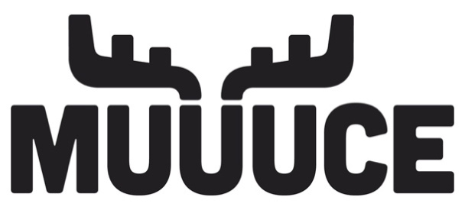
MUUUCE ADULT REGISTRATION FORM

MUUUCE stands for the Most Unbelievable, Ultimate, Urban Camping Experience. This incredible event is designed specifically with middle schoolers in mind. It’s three days of crazy middle school fun, woven with worship experiences, challenging talks, and small group conversations! It’s August 10-12, 2023, at Buffalo Covenant in Buffalo, MN.

FEE OF $ _______________________ IS DUE BY ______________________

MAKE CHECKS PAYABLE TO:_______________________________________________

Adult Leader Registration Packet:
- Read through the Qualifications.
- Complete the registration form.
- Sign the CONSENT & MEDICAL RELEASE.
- Return everything along with your registration fee to the MUUUCE leader at your church.

Qualifications
- Leaders must be at least 18 years of age by August 4, 2023 & have graduated from high school & have an approved background check.

- MUUUCE requires criminal background checks for every adult serving at MUUUCE. Background checks must be no older than August 4, 2021. Please let your MUUUCE leader or church administrator know immediately if you have not completed a background check or if your background check is more than two years old. Your registration will not be complete until MUUUCE confirms a current background check.

- Compliance with the following standards of conduct is expected of all leaders & participants at MUUUCE. If you fail to comply, you may be sent home at your own expense.
  - Use &/or possession of alcohol &/or other controlled substances, fireworks, firearms, or other dangerous weapons (e.g. knives, slingshots, laser pointers, etc.) during MUUUCE is prohibited.
  - Individuals are liable (& will be billed) for any damage they intentionally or accidentally commit to Buffalo Covenant or to MUUUCE property.
  - All students are under the supervision of their respective church leaders.
  - Quiet hours are to be observed (no music, yelling, cheerleading, etc.).
  - Smoking, chewing tobacco, or vaping are not permitted at MUUUCE.

MUUUCE ADULT REGISTRATION FORM
All fields are required. please print legibly.

First Name: __________________________________________________________________
Last Name: __________________________________________________________________
Church Registering with: _________________________________________________________
Gender: □ Male □ Female Date of Birth: ______/__________/___________
T-Shirt Size (adult sizes): □S □M □L □XL □2XL □3XL □4XL
Cell Phone: ____________________________________________________________
Do we have permission to text you updates during MUUUCE? Yes No
Mailing Address
Street: ______________________________________________________________________
City/State/Zip: ________________________________________________________________

Medical Concerns:
Medical Insurance company_________________________ ___ Policy # ___________________

Emergency Contact

First Name: ___________________________ Last Name:_____________________________________
Relationship to you: _____________________ Contact Phone #: ___________________________

Do you have any allergies, including food allergies? If yes, please describe. If your student has dietary restrictions, please email MUUUCE@northwestconference.org by August 4 to discuss the available dietary options. Unfortunately, we cannot make dietary accommodations once the event has started.

Does the participant have any chronic illness, or medical conditions, including mental health issues? If yes, please describe.

Is the participant prescribed an inhaler? If yes, please explain any instructions.

List any other information about yourself that an EMT or attending physician needs to be aware of:

Please read and sign the statement below. This provides permission to seek whatever medical attention maybe necessary. It also releases Northwest Conference of the Covenant Church (NWC), Buffalo Covenant Church (BCC), and / or the church's personnel from any liability against personal injury or loss, so long as they are not grossly negligent.
MUUUCE ADULT CONSENT & MEDICAL FORM

I understand the arrangements and believe that necessary precautions and plans for the care of participants will be taken during this event. By participating in any and all MUUUCE activities prepared by the Northwest Conference of the Covenant (hereafter referred to as NWC), Buffalo Covenant Church (hereafter referred to as BCC), and my sponsoring church (hereafter referred to as "Sponsor Church") to, from, and during MUUUCE, I assume all risk and hazards incidental to the conduct of the activities. I release, absolve, and hold harmless the NWC, BCC, and Sponsor Church and all its respective officers, agents, and representatives from any and all liability for injuries arising out of traveling to, participating in, or returning from MUUUCE.

In case of emergency, I hereby give the MUUUCE leadership, staff, or other emergency medical personnel the permission to seek emergency medical treatment in the event that such treatment is deemed necessary by the conference or church staff. I give permission to those administering emergency medical treatment to do so using those measures deemed necessary. I absolve the NWC, BCC and Sponsor Church and/or church personnel from liability in acting on my behalf in this regard, so long as they are not grossly negligent.

Leader’s Name (printed) ______________________________________________________________

Leader’s Signature __________________________________________________________________

Date ____________________

LEADER BACKGROUND CHECK VERIFICATION FORM

Pastor or church administrator: complete a form for each leader participating in MUUUCE. Email the completed forms to MUUUCE@northwestconference.org by July 31. No adult leader will be allowed to participate at MUUUCE without this signed form.
Leader’s First Name: ____________________________________________________
Leader’s Last Name: ____________________________________________________
Company (i.e. Protectmyministry.com, MinistrySafe.com) that performed the background check:

Date of background check*: / /
*The church must have conducted the background check on, or after, August 4, 2021.

What was covered in the background check?
- Identity verification | - Motor vehicle record
- Database criminal search | - State driving record
- Sex offender’s registry | - Other
- County court record search

This adult is approved to work with minors:  Yes  No

A church representative (senior pastor or church office administrator) must sign this document; you cannot sign for yourself. Please either mail with your final payment or email the completed form to MUUUCE@northwestconference.org

Church

Printed Name: Signature:

Title: Date / /

